**Ad-Supported Users vs. Premium Subscribers (2019 – 2024) in Million:**

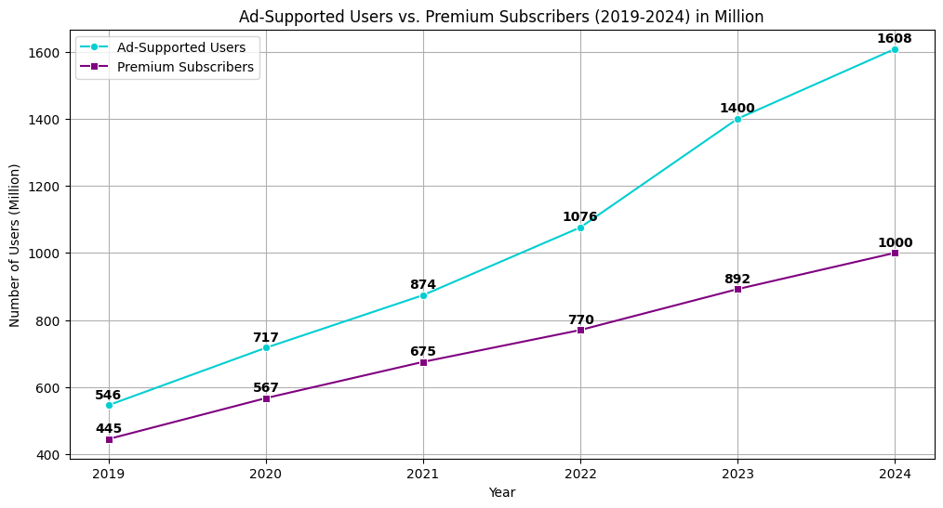

Detailed explanation:

The line chart shows a **steady rise** in both **ad-supported** and **premium users** from **2019** to **2024**, with **ad-supported users consistently outnumbering premium subscribers**. While **free-tier users grew rapidly**, reaching **1,608M** in **2024**, **premium subscribers increased** at a **slower pace**, reaching **1,000M**. The gap between the two groups widened, indicating that Spotify attracts many new users but faces challenges in converting them into paying subscribers. The color-coded lines illustrate the increase of users for each category.

Key statement:

The strong growth in ad-supported users highlights Spotify’s ability to attract new users, but the slower increase in premium subscribers suggests that converting free users into paying customers remains a challenge.

Additional input:

A **key reason** for the **spike** in **user numbers** between **2020** and **2021** could be the **COVID-19 pandemic**, during which more people turned to **music streaming services for entertainment** while in **lockdown**.